NSW ROGAINING CHAMPIONSHIPS
“THE DRIP” – GOULBURN RIVER NATIONAL PARK
September 17/18, 2011
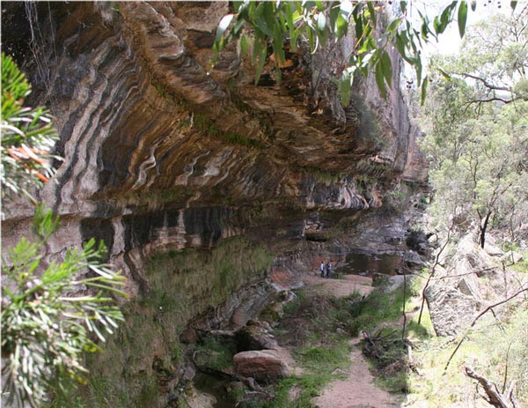
This year’s event is named after the impressive sandstone overhang that features on a section of the Goulburn River near Ulan.
Program: 8:30am Registration opens – maps available
11:30am Briefing for novices
11:45am Final briefing
12 noon Start
3:30pm T & D opens
6:00pm Hash House opens
9:00am T & D closes
12 noon Finish
12:30pm Presentation
The course and its hazards
The terrain is a relatively flat plateau cut by deep streams resulting in a rugged landscape dissected with many cliffs and knolls. Much of the course uses the Goulburn River National Park, but also includes several private holdings. Height varies from about 500 m above sea level, down to 350 m in the Goulburn River. The area is a mixture of dry native forest, with little understory and some open grassland. The rivers and creeks can make good walking routes. There are occasional patches of slower vegetation that usually dissipates after several hundred metres. There is drinkable, flowing water in major streams throughout the area (although you may want to treat this water before drinking).
The principal hazards are:
- Cliffs and steep rocky ground. Some of the larger cliffs along the Goulburn River are 60 metres high. However, you will find significant cliffs scattered across the course. Not all cliffs have been mapped, so treat with respect any areas where the contours are closely spaced.
Cliffs are marked on the map with a standard solid black line with tags. You must not attempt to ascend or descend these marked cliffs. When you encounter a cliff, show some patience, and traverse along the cliff line until a safe passage becomes apparent.
- Getting lost. The course covers about 70km² and has few tracks. There are plenty of helpful line features on the map (typically the River and creeks), but there are plenty of opportunities to become disoriented if you don’t take care to regularly check your location. The course-setters’ final instructions (distributed on the day of the event) will give you advice on safety bearings if you do become lost.

- Scratchy vegetation. While there is next to no scrub on the course, we recommend full body cover to protect yourself from some of the spikier vegetation.

- The Goulburn River. The river has a sandy bottom and, depending on recent rain, can be crossed with dry feet if you take your time to walk around the large pools.
The map
The map has a scale of 1:25000 with 10 metre contours. While the map has developed from Lands Department topographic maps, aerial photographs, Moolarben Coal maps, and some fieldchecking, we can’t guarantee that we haven’t missed a few features.
The map is printed on a glossy A2 sheet but is not waterproof. We recommend that you use a map bag or cover the map with contact. The checkpoint descriptions are printed on the front of the map.
Notes
- Please bring your own water. While we’ll have water for the catering, you can help make it last by using your own.
- We recommend that you carry 3 litres of water on the course if you are contemplating staying out for an extended period. Apart from the hash house, the only drinking water drop will be at the tea and damper checkpoint. There is flowing water in the River and the larger creeks, but you may want to treat it before drinking.
- Apart from the official campfire, no open fires are allowed.
- Use the portable toilets to avoid fellow rogainers having nasty surprises.
- You can camp at the assembly area on the Friday night before the event through to, and including, the Sunday night after the event.
- The assembly area is on private land, and about 20% of the competition area is privately owned. The remainder is national park. Please show respect for the area – we may want to use it again.

Event Registration:
Prior to the Event:
Before you register please ensure:
- You have your team number
- The Indemnity form completed and signed by all team members
- All fees etc paid
- Compulsory equipment – whistle, space blanket, bandages

At registration you will be issued with :
- Map and control descriptions for all team members
- Course setters notes
- One punch card – you do not need to return this to registration before the start
- One NavLight tag and wrist band for each team member
- One Intention Map

Start Procedure
A pre start briefing will be held at 11:45am for all competitors during which time all team members must use the “Brief” punch.
A mass start for both the 24 hour & 15 in 24 hour events will be at 12 noon
During the Event
At each check point, punch the NavLight tag, if it doesn’t work then punch your card manually
Whenever you return to the Hash House the entire team must report to Administration for your tag to be punched with the “Finish”punch
When you are ready to continue you need to report to Administration to have tag punched with the “Depart” punch.

Finish Procedure
At the Finish all competitors must have their tag punched with the finish punch, your finish time will be calculated when the last team members tag is punched. Tags will then be removed and processed at administration

Scoring
- Points for each checkpoint are worth ten times the value of the first number of the checkpoint eg Checkpoint 62 is worth 60.
- Penalty for late finish will be 10 point per minute or part thereof. Zero score will occur if a team arrives over 30 minutes late.
- NavLight will be the primary scoring system, however as a back up if the navLight system malfunctions at a control then punch your card and present it at the finish.

Novices and Inexperienced:
If you are at all unsure about any aspect of Rogaining please ask us. We will be happy to provide advice on navigation, planning your course, route choice, equipment etc. By remaining behind for a few minutes after the start of the event we can give you tips and send you in the right direction.
Hash House:
The Hash House will serve hot food continuously from 6pm (Sat) until1:00pm (Sun) . Your team may return to the hash house at any time during the event but you must register in and out at administration

Tea & Damper
A “Tea & Damper” facility will operate from 3:30pm to 9:00am (Sun). Hot and cold drinks, damper and other treats will be available. The location will be marked on the map

What to bring to the Event (check each item as you pack it )
- Plastic bag or clear contact to protect map and control card
- Indemnity form signed by all members
- Pens, scissors, string, sticky tape for map work
- Your own cutlery, mug, bowl and plate
- Camping gear
- Change of clothes, towel
- Chairs, picnic table
- Food for Friday night and Saturday morning
- Basic first aid kit
- Spare water ( 5 litres )

What to take on the course ( each participant should have these )
- Small backpack
- First aid kit (crepe bandage, elastoplast, “space blanket” )
- Compass, watch, whistle
- Gaiters or other leg coverings (full body cover recommended)
- Shoes with good grip
- Sunhat, suncream, insect repellent
- Wet weather gear and warm clothing
- Headlamp/small torch (with spare batteries and globe)
- Snacks for on the course (staminade, muesli bars, dried fruit, chocolates)
- 1-2 litre filled drink container

Safety
- Your team is required to stay together at all times
- Stay within voice contact of all your team members.
- Stay hydrated
- If an injury or sickness occurs stay together as a team. If able try for the nearest track or checkpoint to wait for other to arrive.
- Whistles should be carried by all team members. Six (6) whistle blasts at 10 second intervals is the distress signal. Any person hearing this signal should render assistance.

Emergency Phone
Phone reception is only available from along ridge lines to a satellite phone at the Hash House the emergency number is : 0147 162 433

Intention Map
Your safety is very important and we try to ensure that if an unfortunate circumstance arises then we can provide assistance for you. Completing the Intention Map will help us in providing such assistance. This is an intention only and not a final route choice for you. Please return it to the information desk.
Directions
From Sydney, travel west on the Great Western Highway through Lithgow. About 6km past Lithgow, take the Castlereagh Highway exit and continue through to Mudgee. From Mudgee, travel north-east towards Cassilis and Merriwa. You’ll pass a left turn to Ulan after about 30km, you’ll cross the Goulburn River after a further 7km, and then turn right (east) onto Durridgerie Road (about 3km past the River). Continue for about 4km on Durridgerie Road to the event site. Allow 4 hours.
From Newcastle, travel north-west on the New England and Golden Highways through Denman and Merriwa, towards Dunedoo. About 50km past Merriwa, turn left (south) towards Ulan and Gulgong. Continue for about 15km and then turn left (east) onto Durridgerie Road. Continue for about 4km on Durridgerie Road to the event site. Allow 3.5 hours.

For any further information contact:
Bob Gilbert - 49521967 bgilbert@hunterlink.net.au

